7COM1079-0901-2025 - Team Research and Development Project

Title: Examining the Correlation Between Theatre Count and Box Office Revenue

Group ID: 226 A

Dataset number: DS056

Prepared by:

Zain ul Abideen 25000790
M. Bilal 23098629
Hamza Ali 24097005
Ali Sufyan 25000826

University of Hertfordshire
Hatfield, 2025
Table of Contents

- Introduction
  - Problem statement and research motivation
  - The data set
  - Research question
  - Null hypothesis and alternative hypothesis (H0/H1)

- Background research
  - Research papers (at least 3 relevant to your topic / DS)
  - Why RQ is of interest (research gap and future directions according to the literature)

- Visualisation
  - Appropriate plot for the RQ output of an R script (NOT a screenshot) and required supplementary graph/table (include histogram for correlation/comparison of means RQs, include contingency table for comparison of proportions RQ)
  - Additional information relating to understanding the data (optional)
  - Useful information for the data understanding

- Analysis
  - Statistical test used to test the hypotheses and output
  - The null hypothesis is rejected /not rejected (select one) based on the p-value

- Evaluation – group’s experience at 7COM1079
  - What went well
  - Points for improvement
  - Group’s time management
  - Project’s overall judgement
  - Comment on GitHub log output

- Conclusions
  - Results explained.
  - Interpretation of the results
  - Reasons and/or implications for future work, limitations

- Reference list
Harvard (author, date) format.
- Appendices
- R code used for analysis and visualisation.
- GitHub log output.

- Introduction

  - Problem statement and research motivation (100 words)
The global film industry produces hundreds of movies each year and generates extensive data on revenue, distribution, and audience engagement over the web. According to the Motion Picture Association of America (MPAA), Adidi et al. (2020), the movie industry has a direct impact on the growth and economy of the country, and the success of a single movie can earn millions of dollars in profit, which has motivated researchers, analysts, and movie makers to understand what drives box office success. While movie popularity and audience interest influence revenue, movie studios invest heavily in theatrical distributions, but it is still unclear how strongly the number of theatres affects a film’s box office revenue. This creates the need for data-driven analysis.

  - The data set (75 words)
The dataset used in this study is provided by the instructor and consists of box office records consist of only 200 data points and the year 2023. The 200 data points in Top_200_Movies_Dataset_2023(Cleaned).csv dataset are organized into 6 columns. This dataset consists of two numeric columns (Rank and Theaters) and four categorical columns (Distributor, TotalGross, Title, and ReleaseDate). For this research study, two variables (Theaters and Total Gross) were selected because they directly measure market reach and financial success.

  - Research question (50 words)
RQ: “Is there a positive correlation between the number of theatres a movie opened in and its total gross revenues?” The motivation comes from literature and a dataset that contains numeric theaters and total gross, making it a perfect choice for correlation and a simpler linear regression test, establishing a correlation between two measures.

  - Null hypothesis and alternative hypothesis (H0/H1) (100 words)
The hypotheses are directly derived from the research question, which examines the relationship between theater distribution and box-office revenue. The null hypothesis (H₀) states that there is no linear correlation between the number of theaters and total gross (ρ = 0). H₀ tests that a change in the count of theaters does not systematically influence the earnings. The alternative hypothesis (H₁) proposes that there is a nonzero linear correlation between theater count and total gross (ρ ≠ 0), indicating that revenue tends to increase or decrease as theater count changes. These two hypotheses guide this research study on which specific statistical test needs to be performed.

- Background research

  - Research papers (at least 3 relevant to your topic / DS) (200 words)
Movie success analysis has long been a prominent marketing research topic. Knowing which films are likely to succeed or fail at the box office is of great interest to all filmmakers. Several studies from the literature utilize various techniques, such as statistical analysis and machine learning, to investigate elements that directly affect the success of movies. Abidi et al. (2020) investigate elements inside the data's hidden patterns that contribute to the popularity of movies. They used the IMDb database to analyze movie performance with machine learning models and showed that selecting the right variables boosted model performance. Other studies, such as Kim et al. (2020), used methods like social networks and text mining algorithms for analyzing Hollywood movies. Their study differs in method, focusing on title keywords and their relationship with Return on Investment (ROI), which reinforces that specific movie characteristics can affect commercial success. More recently, Lase et al. (2024) used linear regression on the Top 2023 box office dataset by studying different variables together that affect movie revenue and reported that there is a strong positive correlation between the number of theaters and total gross, indicating that theatrical reach is a key element of revenue.
.
  - Why RQ is of interest (research gap and future directions according to the literature) (100 words)
The literature reveals that a number of studies have employed various approaches and strategies to examine movie data, concentrating on textual elements, social network aspects, or machine learning models. Kim et al. focused on title keywords, and Abidi et al. employed comparison algorithms; the lack of analysis on different basic structural aspects also affected the box-office performance. The Top 200 movies were employed in a recent study by Lasa et al. (2024) that combined several factors into a multivariable model. Furthermore, they employed a basic regression model without performing several statistical tests, such as Pearson/Spearman correlation, hypothesis testing, or verifying regression assumptions. Lack of different diagnostic plots with Breusch-Pagan.

- Visualisation

Before performing the statistical test, several visualizations were generated, including the main scatter plot (theaters vs. total gross) and additional histograms of total gross and theaters. The main scatter plot was chosen because it directly visualizes the relationship central to this research study. The other plots were added to understand the distribution and relationship between variables and confirm whether correlation analysis and linear interpretation are appropriate.
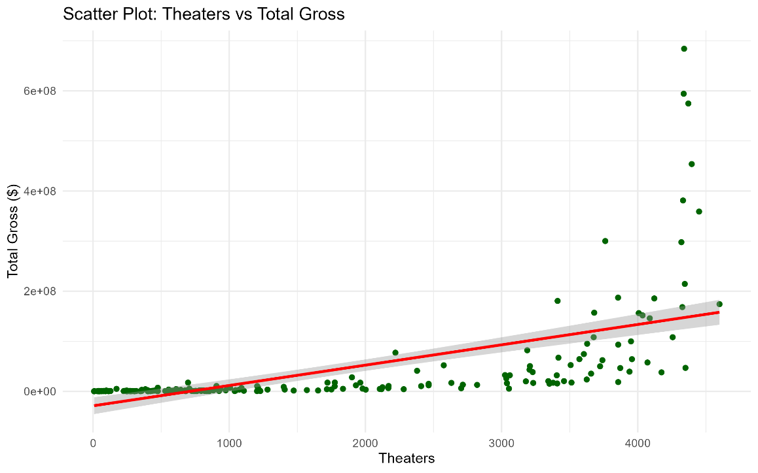
Figure 1: Scatter plot of number of theaters against total gross revenue, with regression line and 95% confidence interval

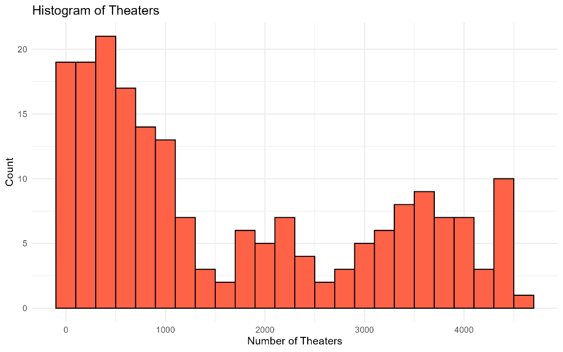
Figure 2: Distribution of the number of theaters in which movies were released

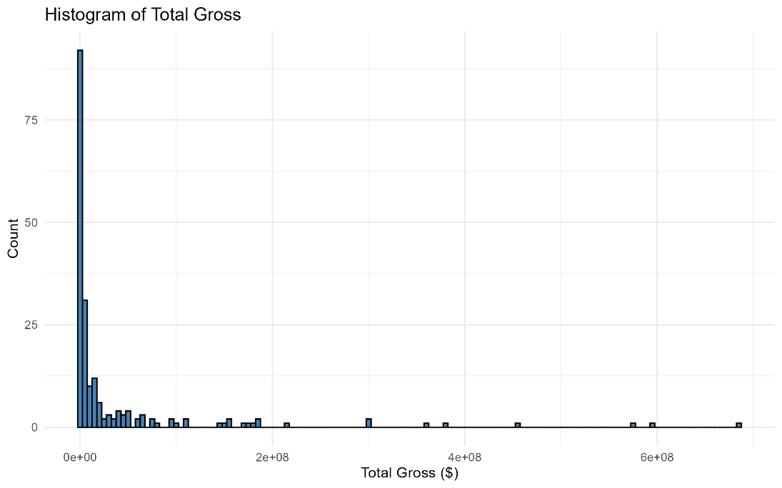
Figure 3: Distribution of total gross revenues across all movies highlights the skewed nature of box-office earnings

  - Additional information relating to understanding the data (optional) (50 words)
- Theaters vs Total Gross Scatter plot reveals a clear positive trend between the number of theaters and total gross revenue.
- Histogram of Total Gross shows that gross revenue is extremely right-skewed.
- The histogram of Theaters shows a bimodal distribution; more likely two patterns are observed: limited release vs wide release.

  - Useful information for the data understanding (50 words)
The histograms reveal strong skewness in both variables. Specifically, total gross is dominated by a few high-earning movies, and theaters count form two clear clusters, which shows that the datasets contain outliers and uneven distributions. The scatter plot directly addresses the research questions and together all these visualizations supporting the use of correlation analysis and linear modelling.

- Analysis

  - Statistical test used to test the hypotheses and output (75 words)
The research question investigates the relationship between two continuous numerical variables (Theaters and Total Gross), and the most appropriate statistical methods are correlation and simple linear regression. Pearson correlation tests linear association; for handling non-normality in the data, Spearman correlation is included. Regression analysis tests are performed to test whether the number of theatres statistically predicts total gross revenue. Additionally, for validating model assumptions, diagnostic plots and the Breusch-Pagan test were performed.

  - The null hypothesis is rejected /not rejected based on the p-value
Table:1 Summary of statistical tests includes Pearson and Spearman correlations

Test | Statistic | p-value | Decision (α = 0.05) | Conclusion
Pearson Correlation (r) | 0.601 | 7.31 × 10⁻²¹ | Reject H₀ | Strong, significant linear correlation between theaters and total gross
Spearman Correlation (rho) | 0.899 | 3.01 × 10⁻⁷² | Reject H₀ | Very strong monotonic relationship, confirming positive association.
Linear Regression (Raw Slope) | 40,602 | 7.31 × 10⁻²¹ | Reject H₀ | Theaters significantly predict total gross revenue.
Linear Regression (Log Slope) | 0.00138 | 8.73 × 10⁻⁸¹ | Reject H₀ | Theaters significantly predict log(gross); this is the best model.
Breusch–Pagan Test | — | 0.1877 | - | No heteroscedasticity: regression assumptions are satisfied.

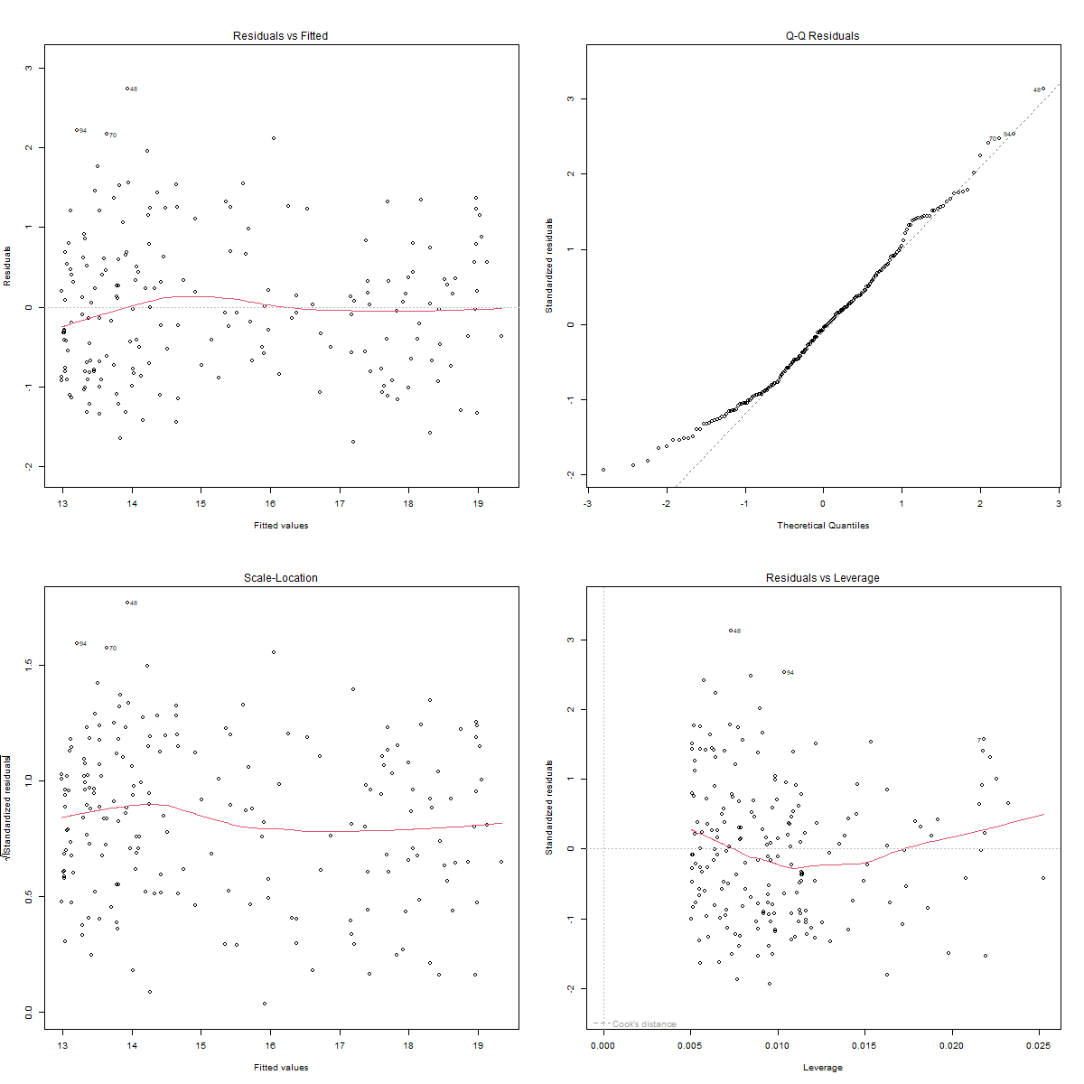

Figure 4: Diagnostic plots for the log-transformed regression model, histogram of residuals, QQ-plot, residuals vs fitted values, and leverage plots used to assess model assumptions and identify outliers or influential cases

Based on the statistical test performed, the table of results clearly shows that the null hypothesis of “no relationship” is rejected for all analysis methods except the Breusch-Pagan diagnostic. Both Pearson and Spearman p-values are less than 0.001, which proves that correlations show a significant positive association between the number of theatres and the total gross revenue. The linear regression model test also produces very small p values that confirm that theatres have a significant predictive revenue even after long transformations. The Breusch-Pagan test gives a non-significant p-value, but regression assumptions are met, and the model is reliable.

- Evaluation – group’s experience at 7COM1079

  - What went well (75 words)
This research project taught our group the most important skills of teamwork, project management, and peer learning. Everything from the start is organized and planned by the group leader. The collaborative GitHub repository was created to efficiently manage changes and track progress, and tasks were divided among each member. GitHub logs clearly showed that each member participated equally throughout the project life cycle and in report writing. Overall, this project gave us motivation and the necessary knowledge to work in collaborative environments and to apply statistical knowledge systematically.

  - Points for improvement (75 words)
A key challenge for some group members was a knowledge gap in statistical comprehension and interpretation. Tasks such as choosing which statistical tests need to be performed to test hypotheses, understanding their assumptions, and writing diagnostic code require time to grasp. There is a need for a strong understanding of statistical concepts and their effective application to accomplish work. Additionally, we observed a need to understand version control systems and their importance in collaborative environments.

  - Group’s time management (50 words)
Time management is the most important skill in every project, and as mentioned earlier, due to earlier project management, the selection of a systematic workflow and task division helps us to achieve each member's assigned task on time. Additionally, because of GitHub's proper version control system, each member completes their task and commits their work accordingly, which helps to make progress quickly and finish the entire project on time.

  - Project’s overall judgement (50 words)
Although due to some knowledge gaps in statistical knowledge, this project achieved a high success score because of a clear, systematic workflow, project management, task division, and a peer learning collaborative environment. Our goal extends beyond just completing the project; we emphasize analytical thinking when selecting statistical tests, interpreting visualizations, and supporting one another in completing tasks.

  - Comment on the GitHub log output (50 words)
The GitHub logs (shown in Appendix B).
- Commit Message: Remove commas and weird symbols in Theaters and Total Gross columns. This commit was very useful for the next member who was assigned the data exploration and visualization tasks that needed to be performed on a clean dataset.
- Commit Message: Test how much increases when theatre goes up by linear regression. This commit is helpful for providing insights into data distribution patterns and their statistical importance.
- Commit Message: Create Histogram of residuals checks. When all tests are performed, there is a need to check model assumptions, and this commit is helpful for the completion of the project.

- Conclusions

  - Results explained (75 words)
The primary motivation for this study is to test statistically whether a correlation exists between the number of theaters and total gross revenue, and the results clearly proved the alternate hypothesis that a correlation exists. Different statistical tests were performed to test these hypotheses, all of which reject the null hypothesis, indicating a statistically significant relationship between the two variables. Positive association is clearly proved when applying the Pearson and Spearman correlation tests. The number of theaters directly impacts the total gross, as clearly proved by regression models, and diagnostic tests confirm that the model assumptions are statistically valid.

  - Interpretation of the results (75 words)
The rejection of the null hypothesis clearly shows that theater count is a key factor of box-office performance, which means that films shown in more theaters earn more money than those released in fewer theaters. From a corporate and real-world standpoint, more theatrical distribution leads to increased public recognition, audience reach, and, eventually, more earnings, which boosts the economy. From the perspective of movie studios, this emphasizes the strategic importance of and distribution of theaters.
.
  - Reasons and/or implications for future work, limitations of your study (50 words)
One of the study's major limitations is that it only includes 200 of the highest-grossing movies. Future work incorporated other variables such as genre, ratings, budgets, and marketing spending. This study is similarly limited to one research issue, which is to test correlation. It might be used to evaluate more statistical tests and discover patterns and insights in the data that could be beneficial to filmmakers and producers.

- Reference list

Abidi, S.M.R., Xu, Y., Ni, J., Wang, X. and Zhang, W. (2020). Popularity prediction of movies: from statistical modeling to machine learning techniques. Multimedia Tools and Applications, 79(47-48), pp.35583–35617. doi:https://doi.org/10.1007/s11042-019-08546-5.
Kim, J.-M., Xiao, X. and im, I.K. (2020). HOLLYWOOD MOVIE DATA ANALYSIS BY SOCIAL NETWORK ANALYSIS AND TEXT MINING. International Journal of Electronic Commerce Studies, 11(1), pp.75–92. doi:https://doi.org/10.7903/ijecs.1731.
Lase, Y., Claudia, S., Lingga, I. and Ariyudha, D., 2024. Uncovering the Secrets of the 2023 Box Office: Analysis of Factors Affecting the Success of the Top 200 Films Using the Linear Regression Method. Electronic Integrated Computer Algorithm Journal, 2(1), pp.29-39.

- Appendices

- R code used for analysis and visualisation (not included in the word count)
Analysis.R code with the appropriate statistics to test the hypotheses.
Data Cleaning R Code:
# ===============================
# 1. Load Libraries
# ===============================
library(dplyr)
library(stringr)
library(lubridate)
# ===============================
# 2. Load CSV File
# ===============================

df <- read.csv("D:/7COM1079_Group_Project_Top200Movies/data/Top_200_Movies_Dataset_2023(Cleaned).csv", stringsAsFactors = FALSE)

# ===============================
# 3 FIX THEATERS
# ===============================

df$Theaters <- df$Theaters %>%
str_replace_all(",", "") %>% # remove commas
str_replace_all("[^0-9]", "") %>% # remove non-numeric characters
na_if("") %>% # convert empty to NA
as.numeric()

# ===============================
# 4 FIX TOTAL GROSS
# ===============================

df$Total.Gross <- df$Total.Gross %>%
str_replace_all("[^0-9.]", "") %>% # remove everything except digits
as.numeric()

# ===============================
# 5 CLEAN DISTRIBUTOR
# ===============================

df$Distributor <- df$Distributor %>%
str_replace_all("'-", NA_character_) %>%
str_trim()

# ===============================
# 6 CLEAN TITLES
# ===============================

df$Title <- df$Title %>% str_squish()
# Save result
write.csv(df, " Research_question_analysis_movies_cleaned.csv ", row.names = FALSE)

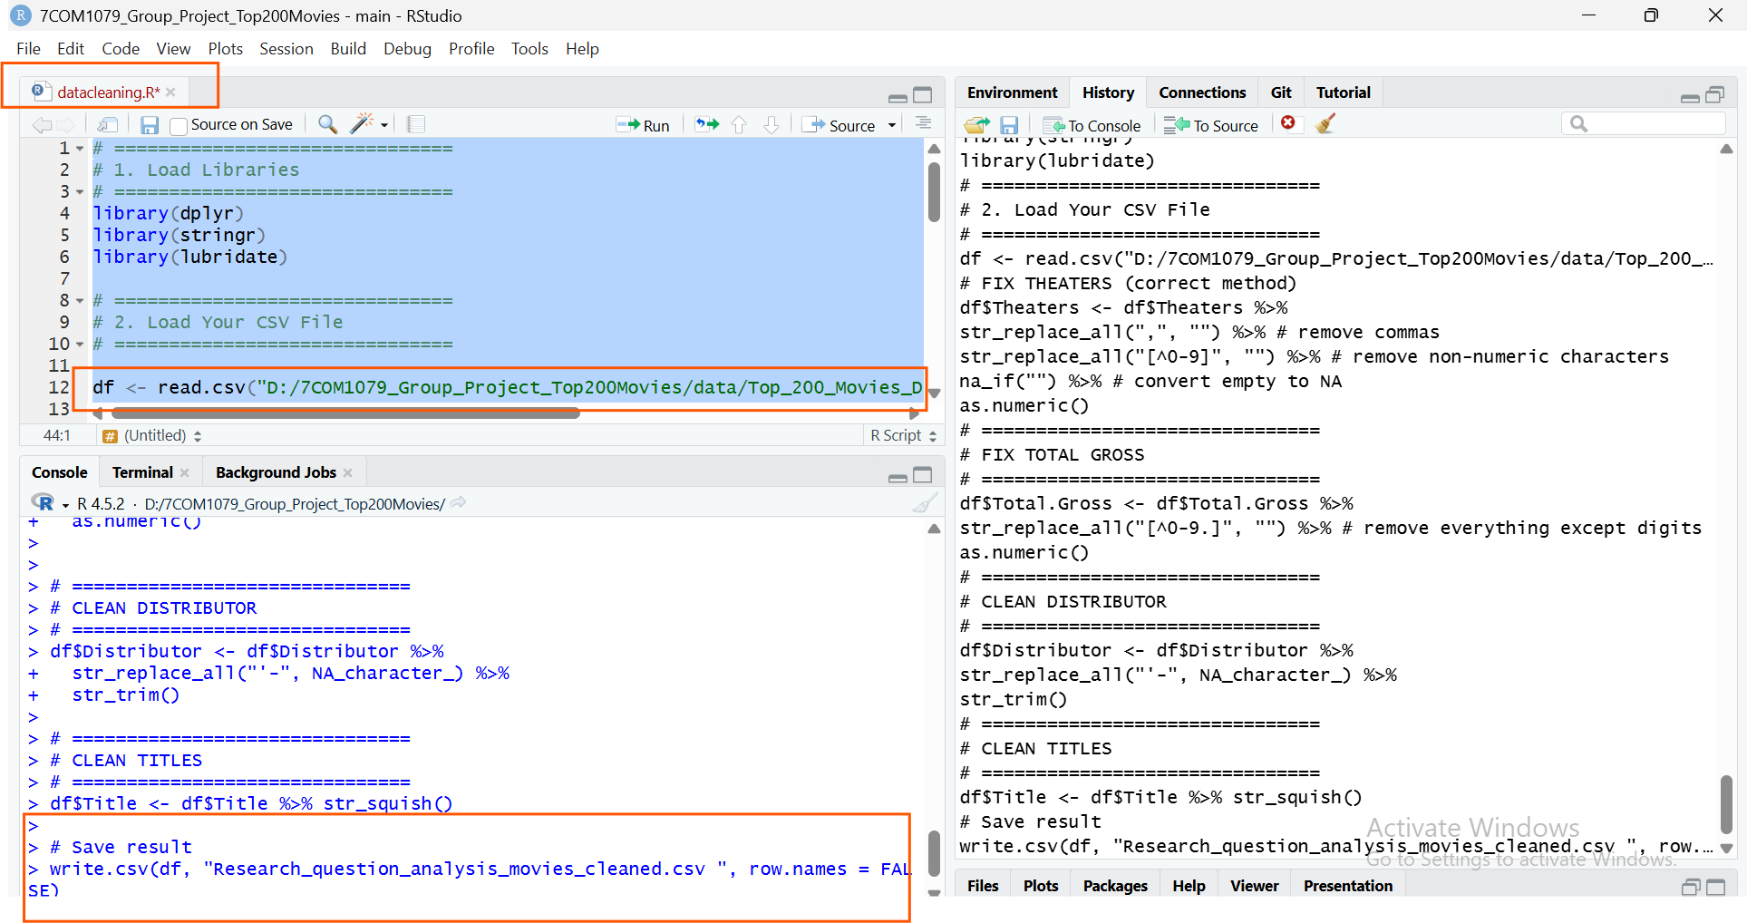

Data Visualizations:

# ===============================
# 1 Load libraries
# ===============================

library(ggplot2)
library(dplyr)

# ===============================
# 2. Load CSV File
# ===============================

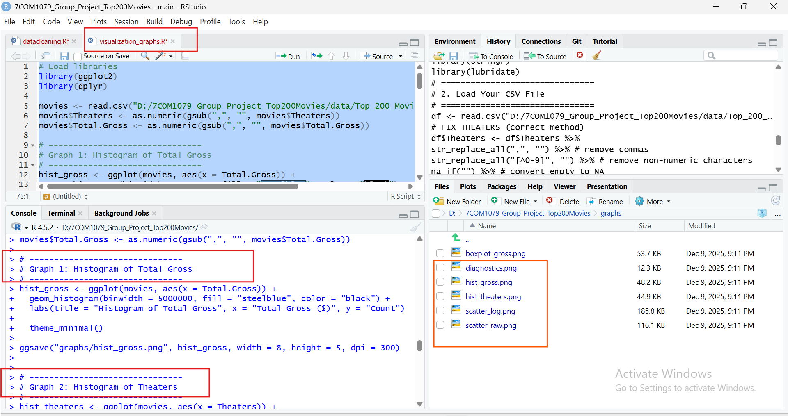

movies <- read.csv("D:/7COM1079_Group_Project_Top200Movies/data/Research_question_analysis_movies_cleaned.csv")
movies$Theaters <- as.numeric(gsub(",", "", movies$Theaters))
movies$Total.Gross <- as.numeric(gsub(",", "", movies$Total.Gross))

# -------------------------------
# 3 Graph 1: Histogram of Total Gross
# -------------------------------
hist_gross <- ggplot(movies, aes(x = Total.Gross)) +
geom_histogram(binwidth = 5000000, fill = "steelblue", color = "black") +
labs(title = "Histogram of Total Gross", x = "Total Gross ($)", y = "Count") +
theme_minimal()

ggsave("graphs/hist_gross.png", hist_gross, width = 8, height = 5, dpi = 300)

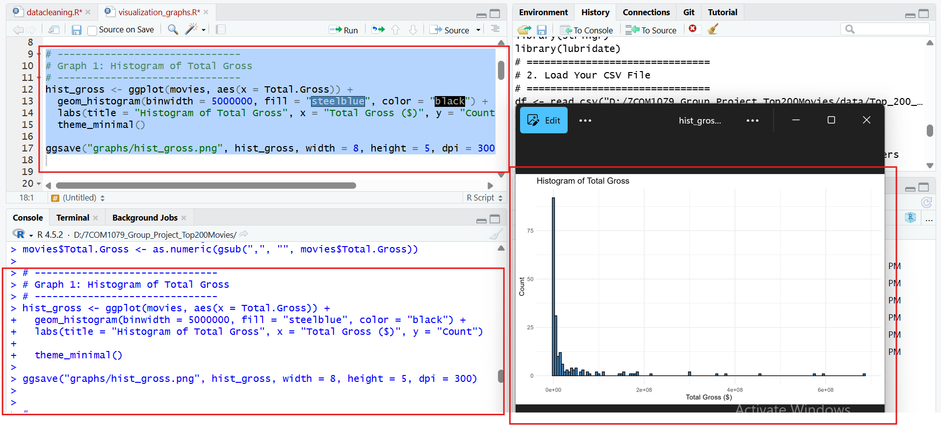

# -------------------------------
# Graph 2: Histogram of Theaters
# -------------------------------
hist_theaters <- ggplot(movies, aes(x = Theaters)) +
geom_histogram(binwidth = 200, fill = "tomato", color = "black") +
labs(title = "Histogram of Theaters", x = "Number of Theaters", y = "Count") +
theme_minimal()

ggsave("graphs/hist_theaters.png", hist_theaters, width = 8, height = 5, dpi = 300)

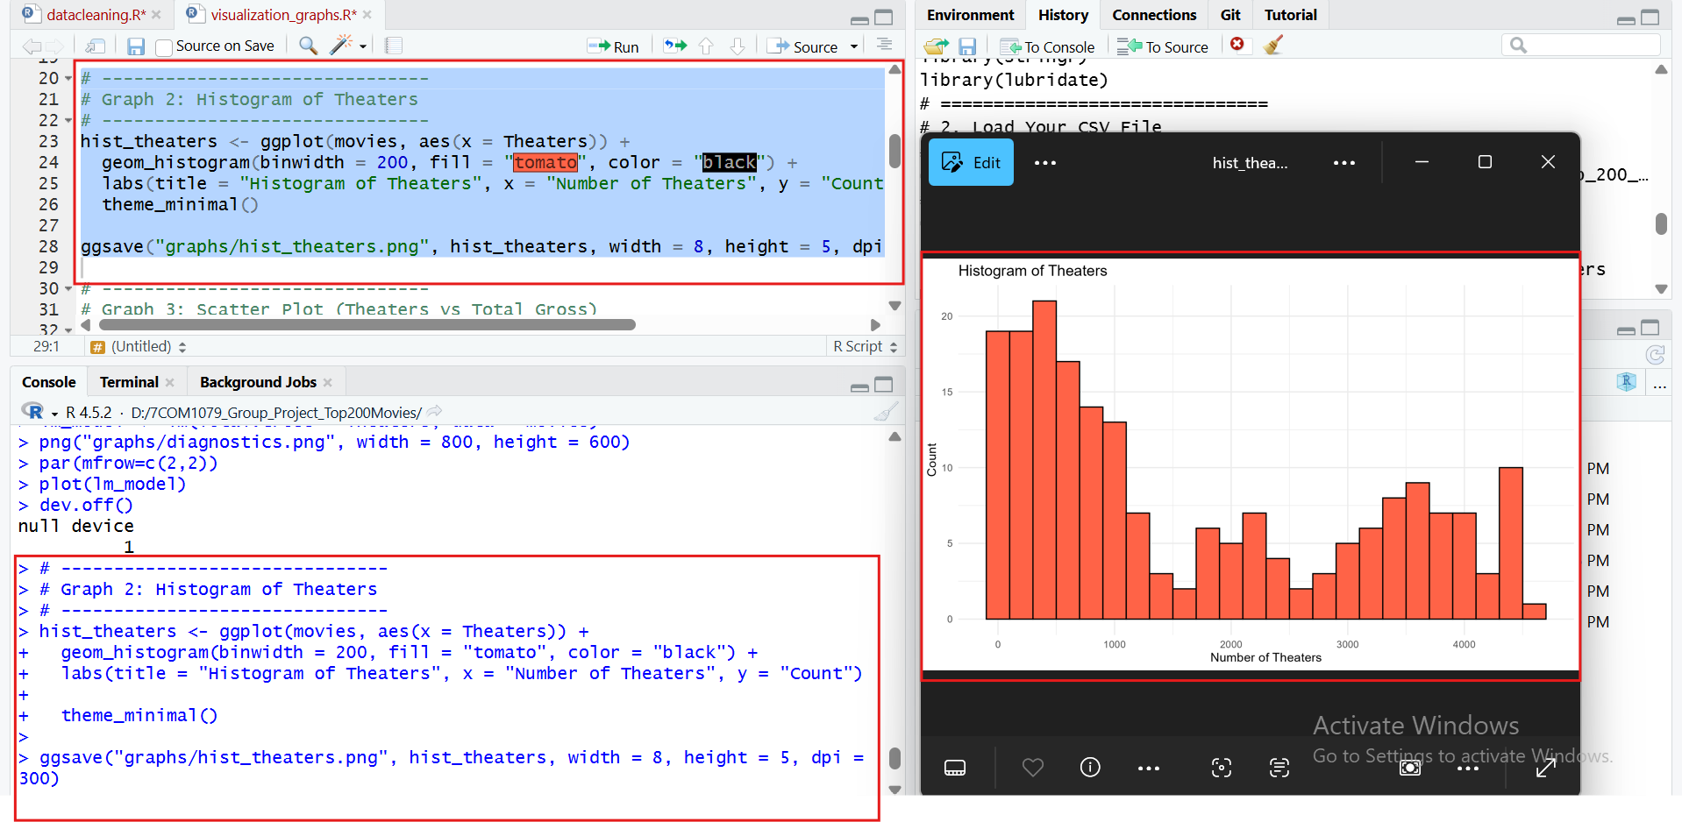

# -------------------------------
# Graph 3: Scatter Plot (Theaters vs Total Gross)
# -------------------------------
scatter_raw <- ggplot(movies, aes(x = Theaters, y = Total.Gross)) +
geom_point(color = "darkgreen") +
geom_smooth(method = "lm", color = "red", se = TRUE) +
labs(title = "Scatter Plot: Theaters vs Total Gross", x = "Theaters", y = "Total Gross ($)") +
theme_minimal()

ggsave("graphs/scatter_raw.png", scatter_raw, width = 8, height = 5, dpi = 300)

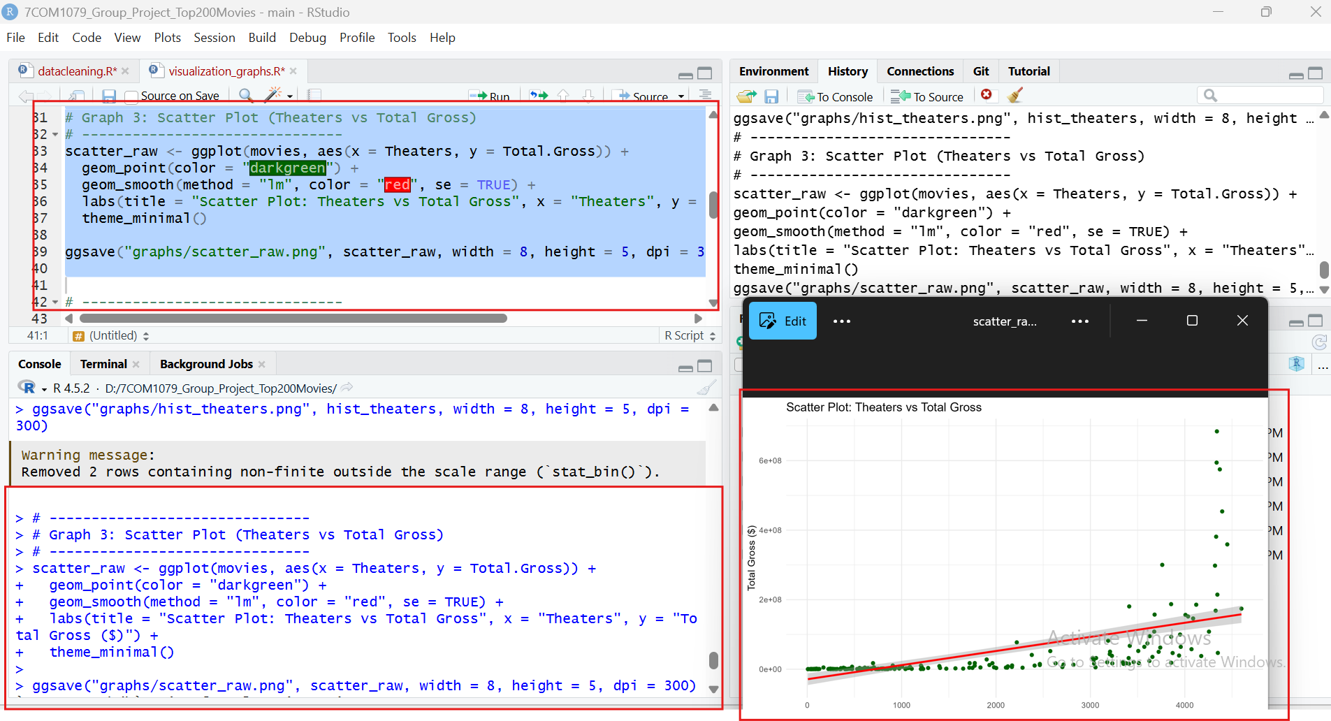
# -------------------------------
# Graph 4: Scatter Plot (Log scale Y)
# -------------------------------
scatter_log <- ggplot(movies, aes(x = Theaters, y = Total.Gross)) +
geom_point(color = "darkblue") +
geom_smooth(method = "lm", color = "red", se = TRUE) +
scale_y_log10() +
labs(title = "Scatter Plot: Theaters vs Total Gross (Log Y)", x = "Theaters", y = "Total Gross (log $)") +
theme_minimal()

ggsave("graphs/scatter_log.png", scatter_log, width = 8, height = 5, dpi = 300)

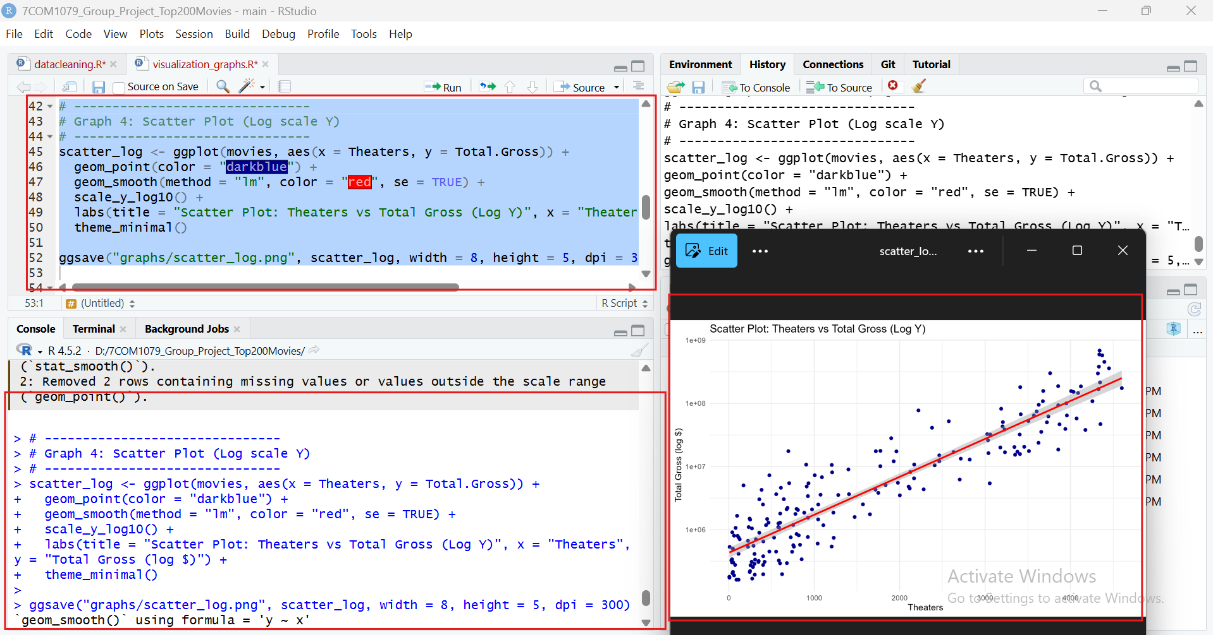

Statistical Test Code:
# ===============================================
# Load data
# ===============================================
df <- read.csv("D:/7COM1079_Group_Project_Top200Movies/data/Research_question_analysis_movies_cleaned.csv")

# Create paths
analysis_path <- "D:/7COM1079_Group_Project_Top200Movies/analysis/"
graphs_path <- paste0(analysis_path, "graphs/")
tables_path <- paste0(analysis_path, "tables/")

dir.create(graphs_path, showWarnings = FALSE)
dir.create(tables_path, showWarnings = FALSE)

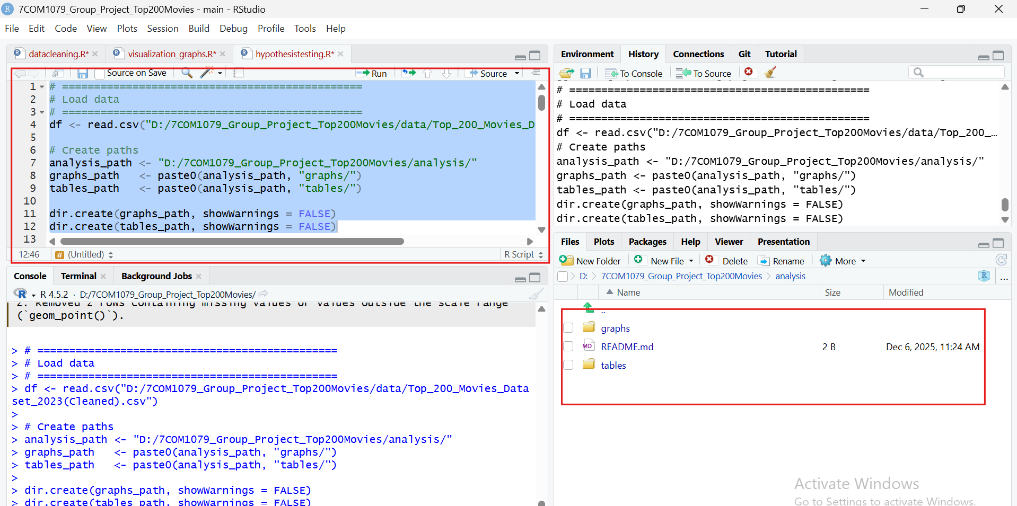

# ===============================================
# Correlation tests
# ===============================================
pearson <- cor.test(df$Theaters, df$Total.Gross, method = "pearson")
spearman <- cor.test(df$Theaters, df$Total.Gross, method = "spearman")

# ===============================================
# Regression models
# ===============================================
model_raw <- lm(Total.Gross ~ Theaters, data = df)

df$logGross <- log(df$Total.Gross)
model_log <- lm(logGross ~ Theaters, data = df)

res <- residuals(model_log)

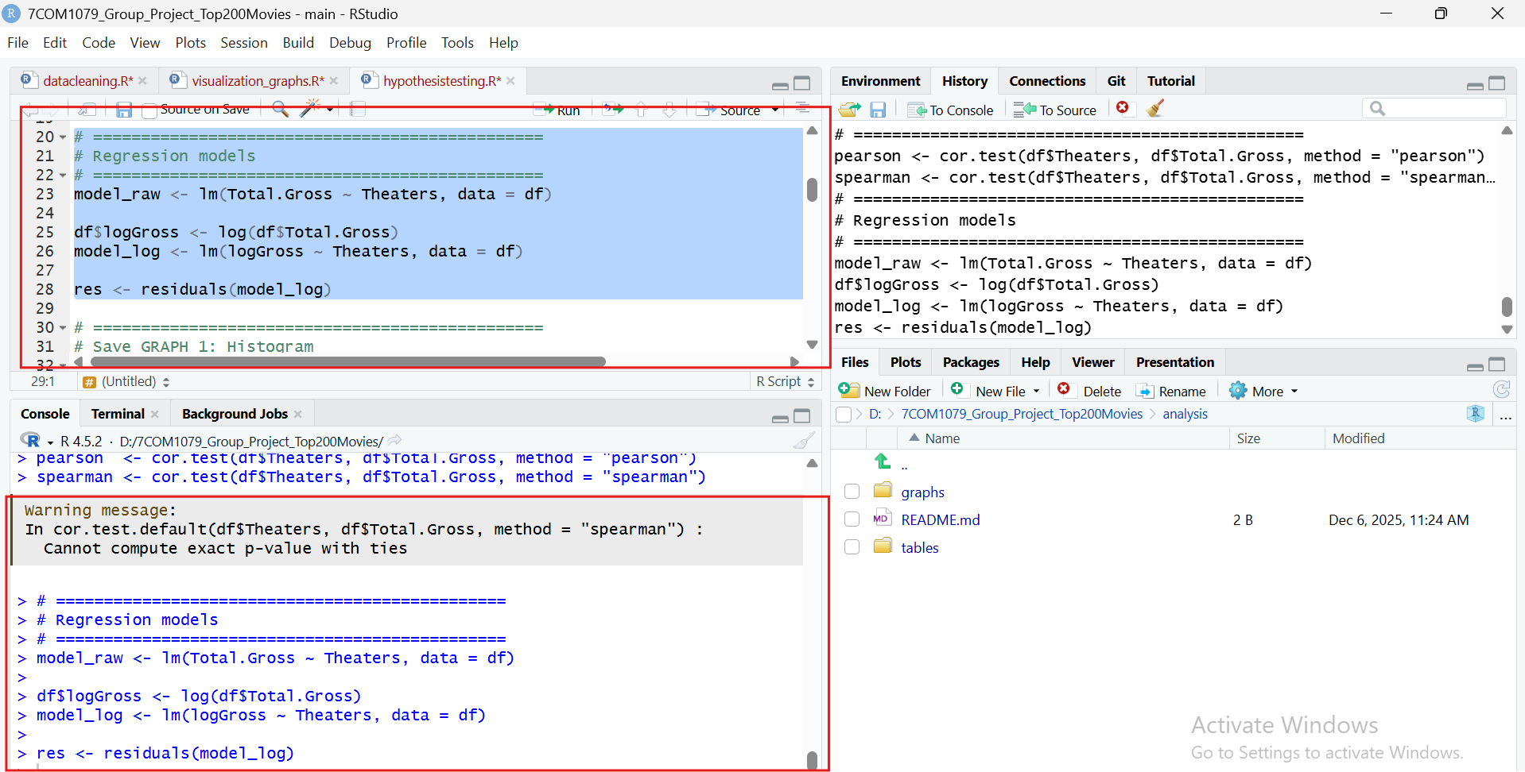

# ===============================================
# Save GRAPH 1: Histogram
# ===============================================
png(paste0(graphs_path, "hist_residuals.png"), width = 1000, height = 700)
hist(res,
main = "Histogram of Residuals",
xlab = "Residuals",
breaks = 20)
dev.off()

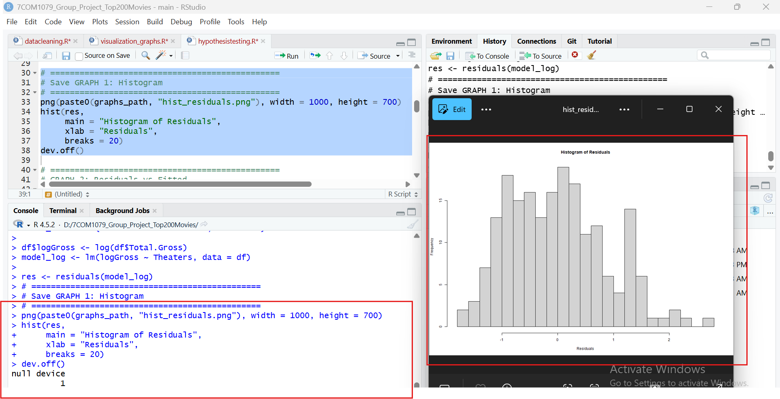

# ===============================================
# GRAPH 2: Residuals vs Fitted
# ===============================================
png(paste0(graphs_path, "residuals_vs_fitted.png"), width = 1000, height = 700)
plot(fitted(model_log), res,
main = "Residuals vs Fitted",
xlab = "Fitted Values",
ylab = "Residuals")
abline(h = 0, col = "red")
dev.off()

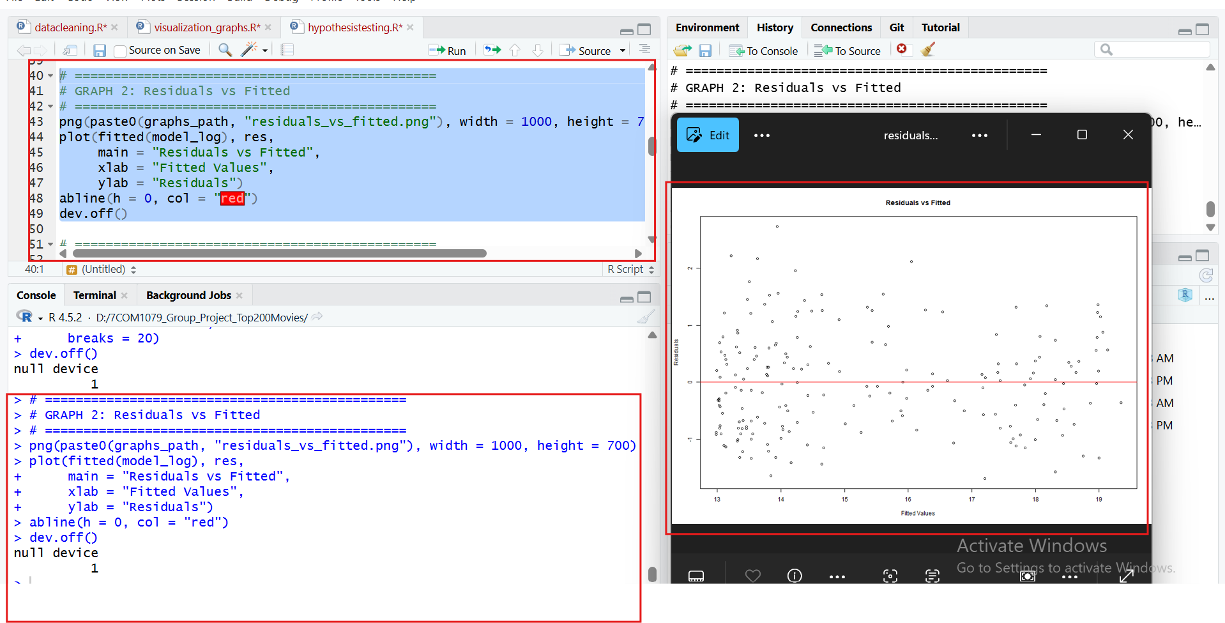

# ===============================================
# GRAPH 3: QQ Plot
# ===============================================
png(paste0(graphs_path, "qq_plot.png"), width = 1000, height = 700)
qqnorm(res, main = "QQ Plot of Residuals")
qqline(res, col = "red")
dev.off()

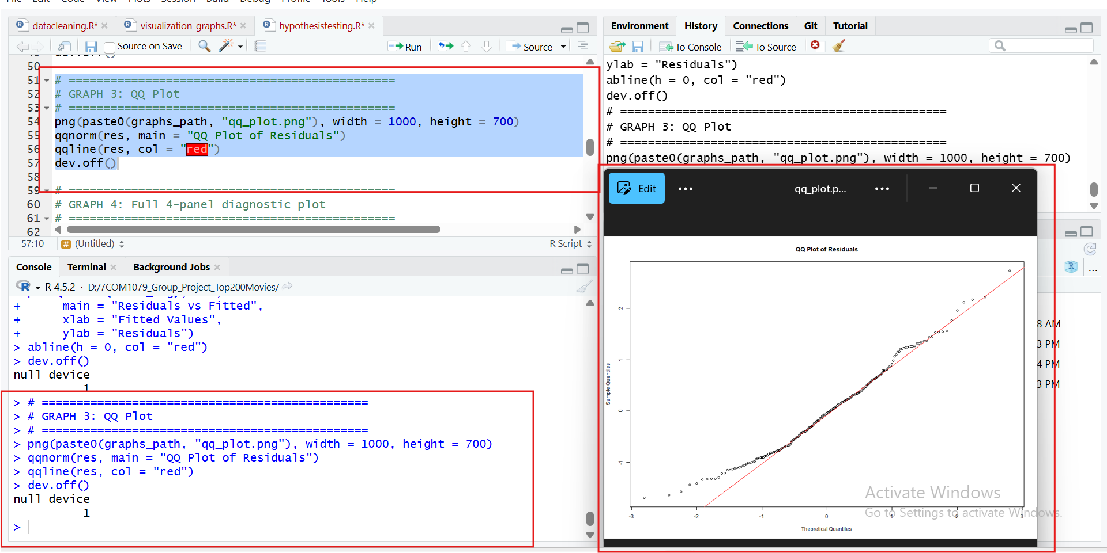

# ===============================================
# GRAPH 4: Full 4-panel diagnostic plot
# ===============================================
png(paste0(graphs_path, "diagnostic_plots.png"), width = 1200, height = 1200)
par(mfrow = c(2,2))
plot(model_log)
dev.off()

# ===============================================
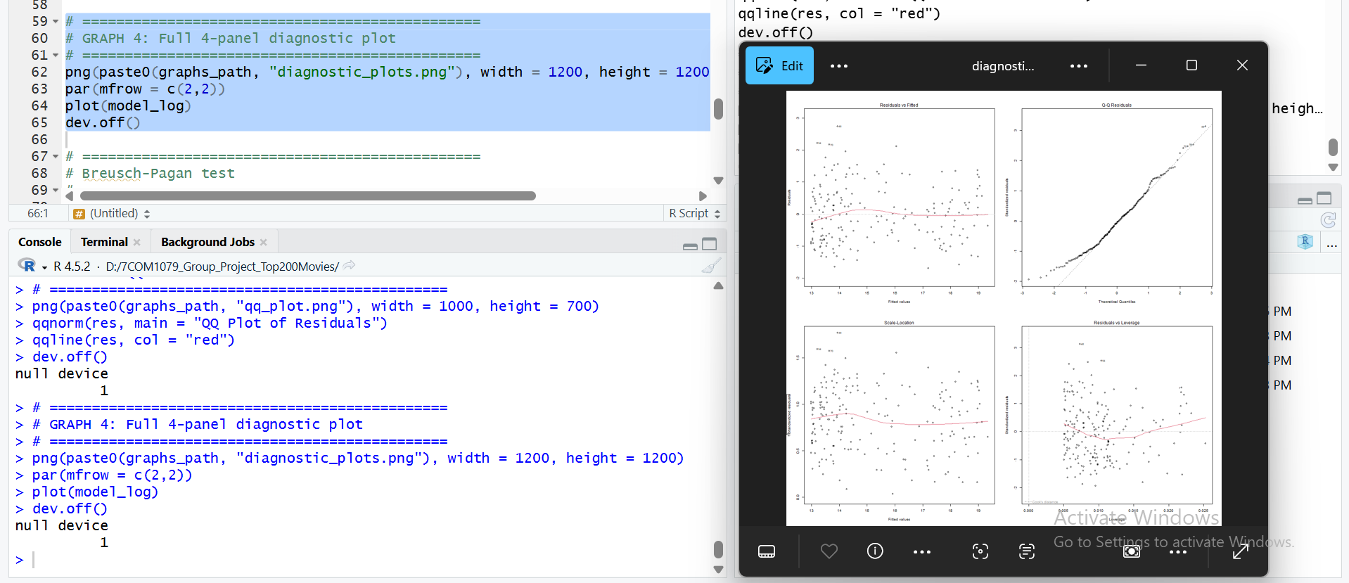
# Breusch-Pagan test
# ===============================================
library(lmtest)
bp <- bptest(model_log)

# ===============================================
# Save statistical results table
# ===============================================
results <- data.frame(
Test = c("Pearson r", "Spearman rho", "Regression Raw", "Regression Log", "Breusch-Pagan p"),
Statistic = c(
pearson$estimate,
spearman$estimate,
coef(summary(model_raw))[2,1],
coef(summary(model_log))[2,1],
bp$p.value
),
p_value = c(
pearson$p.value,
spearman$p.value,
coef(summary(model_raw))[2,4],
coef(summary(model_log))[2,4],
bp$p.value
)
)

write.csv(results, paste0(tables_path, "stat_results.csv"), row.names = FALSE)

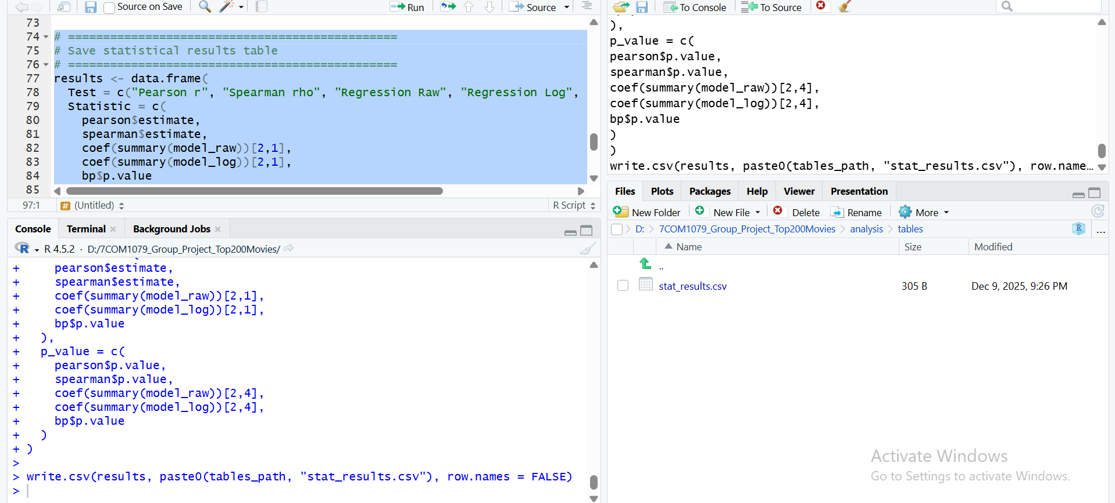

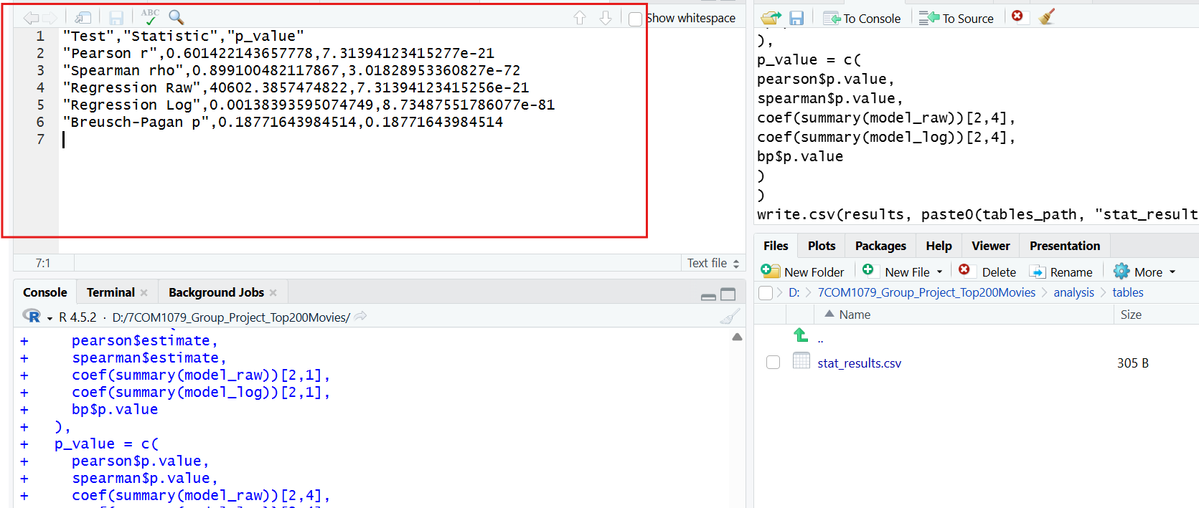

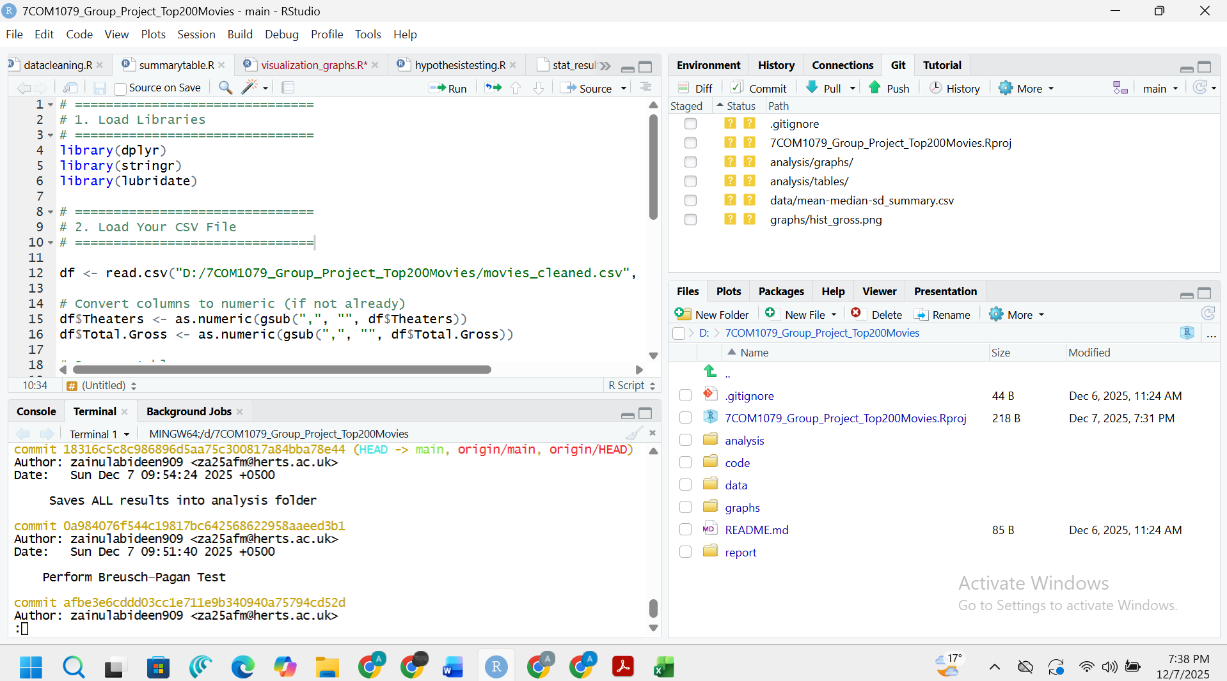

- GitHub log output.

